#### **INSTAGRAM USER ANALYTICS**

#### **Marketing Analysis:**

1. **Loyal user reward:**

**INPUT:**

select * from users

order by created_at asc

limit 5

**OUTPUT:**

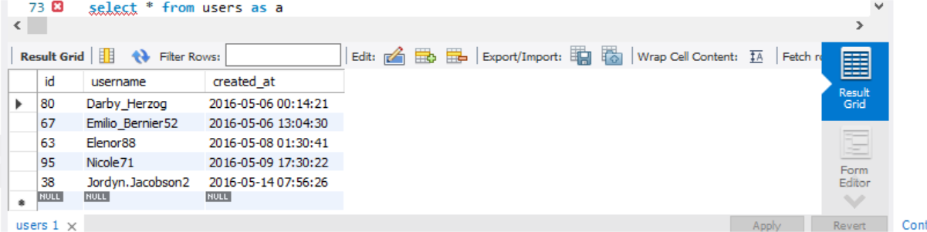

2.Who Have never Photo on Instagram Inactive Engagement

**INPUT:**

select * from users as a

left join photos as b on

a.id = b.user_id and

b.user_id is null

|  |  |  |  |
| --- | --- | --- | --- |
|  |  |  |  |

**OUTPUT:**

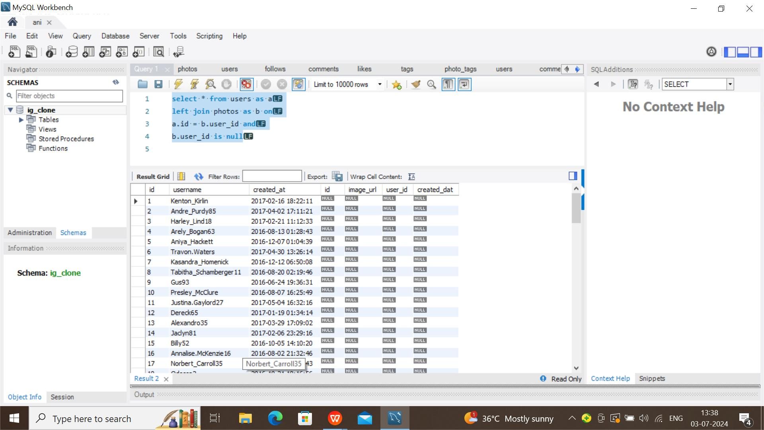

**3.Declaration winner of contest:**

**INPUT:**

**select * from**

**(select user_id , count(photo_id)as count from likes**

**group by user_id**

**order by count desc) as a**

**left join users as b on a.user_id = b.id**

**OUTPUT:**

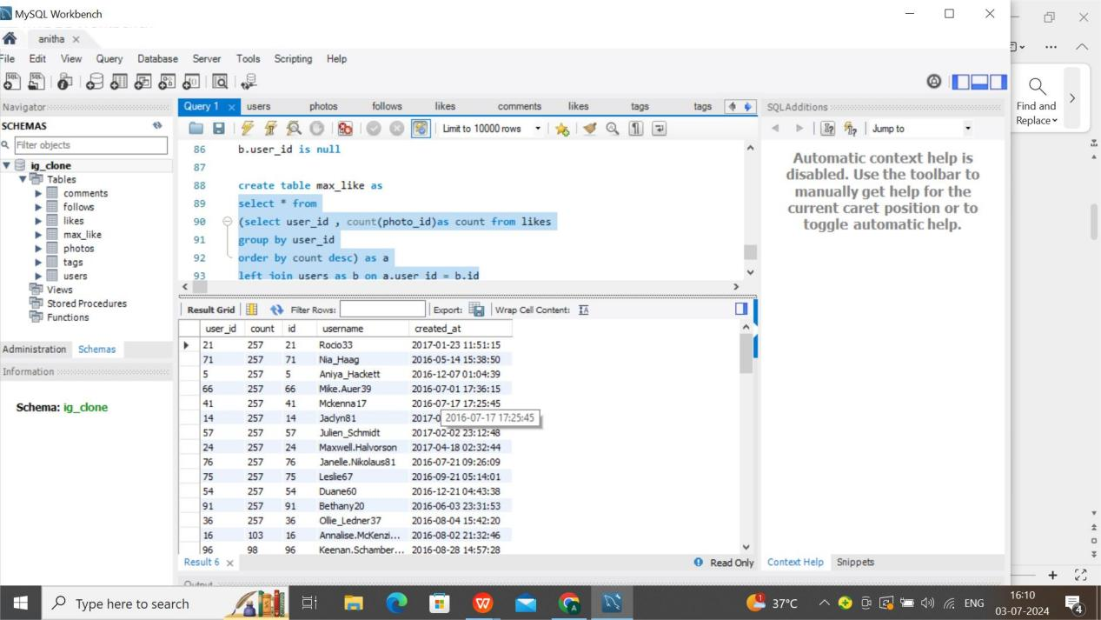

**4. Hashtag Research**

**INPUT:**

**select a.tag_name , count(b.tag_id) as cnt from tags as a**

**left join photo_tags as b**

**on a.id = b.tag_id**

**group by a.tag_name**

**order by cnt desc limit 5**

**OUTPUT:**

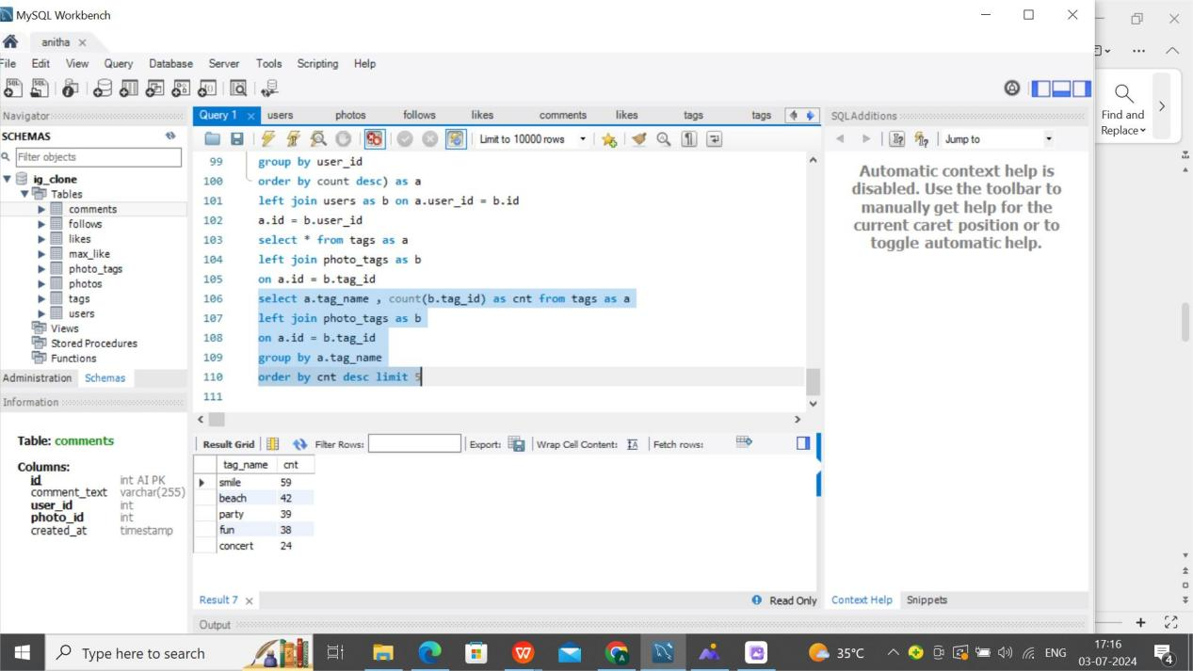

1. **Ad Campaign Launch**

**INPUT:**

**select week(created_at) as wk ,**

**count(week(created_at))as cnt from users**

**group by wk**

**order by cnt desc**

**OUTPUT:**

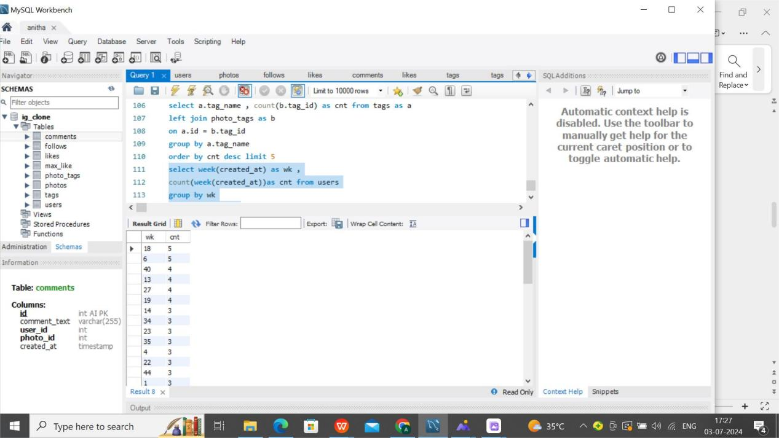

1. **Investor Metrics**
2. **User Engagement:**

**select count(b.image_url) / count(a.id) as avg1 from users as a**

**left join photos as b**

**on a.id = b.user_id**

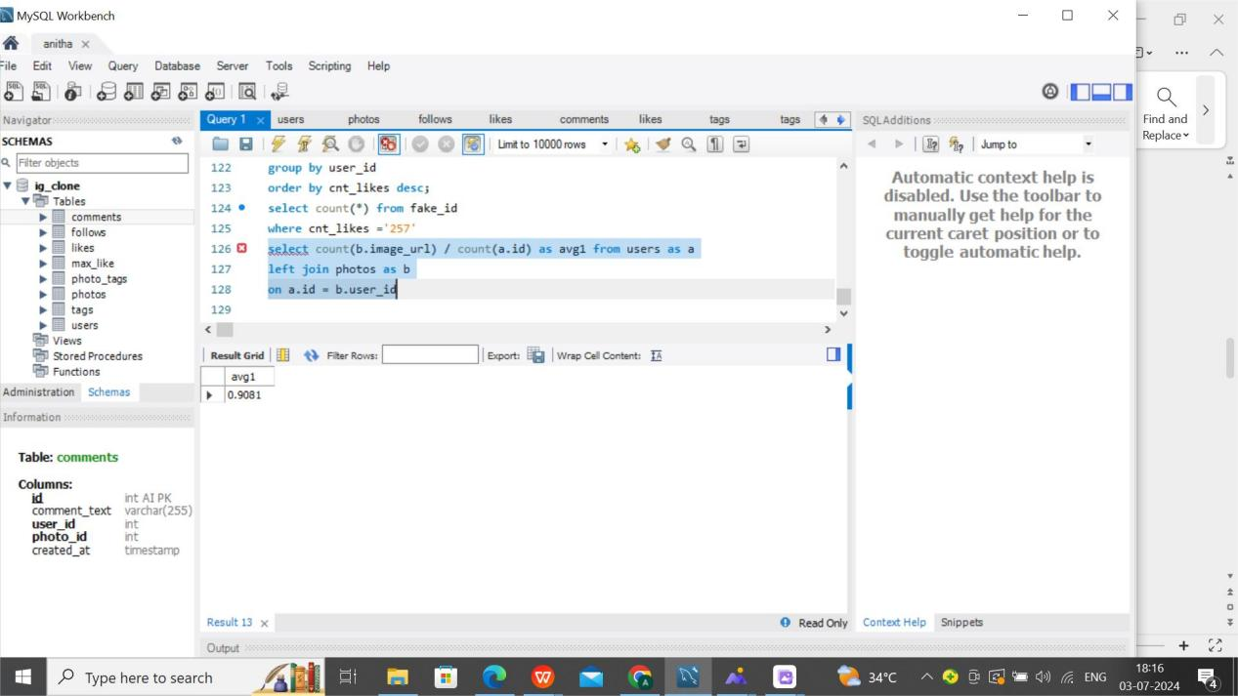

**7. Bots & Fake Accounts:**

**INPUT:**

**select b.user_id , count(a.id) from users as a**

**left join photos as b**

**on a.id = b.user_id**

**group by b.user_id**

#### **OUTPUT:**

#### Screenshot (12)(1)

#### select count(*) from fake_id

#### where cnt_likes ='257'

